Name=Aditya Anal

Profile=Data Engineer

**Linux Command Tutorials**

**Linux:** The Linux command is a utility of the Linux operating system. All basic and advanced tasks can be done by executing commands. The commands are executed on the**Linux terminal**.

Basic Commands :

**1.Pwd:** The pwd command is used to display the location of the current working directory.

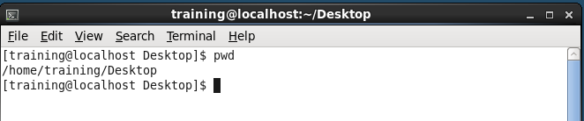

**2. mkdir Command:** The mkdir command is used to create a new directory under any directory.

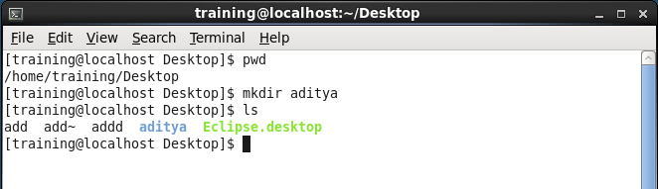

**3. ls Command:** The [ls](https://www.javatpoint.com/linux-ls) command is used to display a list of content of a directory.

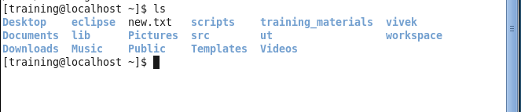

**4. cd Command** : The [cd](https://www.javatpoint.com/linux-cd) command is used to change the current directory.

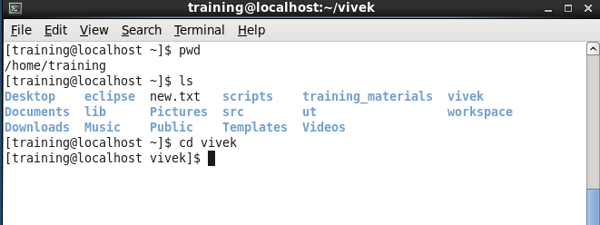

**5. touch Command:** The touch command is used to create empty files. We can create multiple empty files by executing it once.

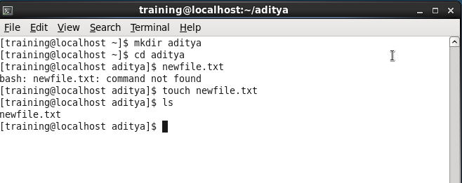

**6. cat Command**: The cat command is a multi-purpose utility in the Linux system. It can be used to create a file, display content of the file, copy the content of one file to another file, and more.

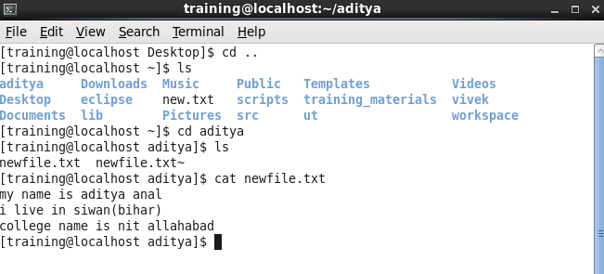

**7. rm Command** : The [rm](https://www.javatpoint.com/linux-rm) command is used to remove a file.

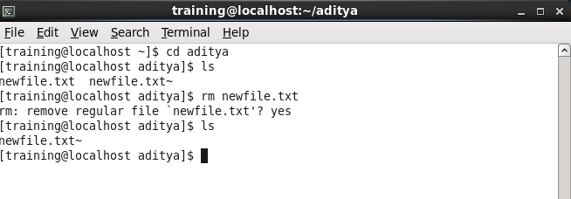**8. cp Command** : The [cp](https://www.javatpoint.com/linux-cp) command is used to copy a file or directory.

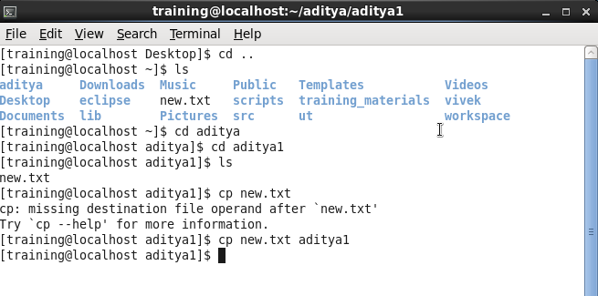

**9. mv Command** : The mv command is used to move a file or a directory form one location to another location.

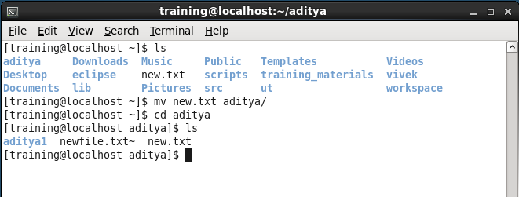

**10. date Command:** The date command is used to display date, time, time zone, and more.

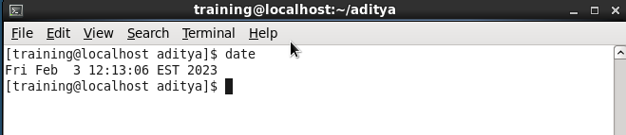

**11. cal Command:** The cal command is used to display the current month's calendar with the current date highlighted.

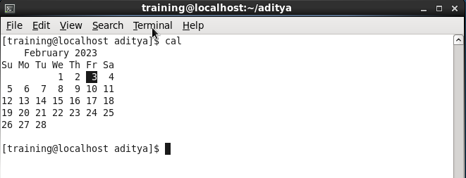

**12. sleep Command:** The sleep command is used to hold the terminal by the specified amount of time. By default, it takes time in seconds.

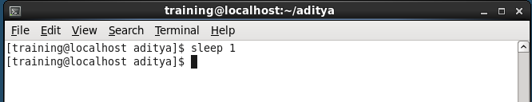

**13. time Command:** The time command is used to display the time to execute a command.

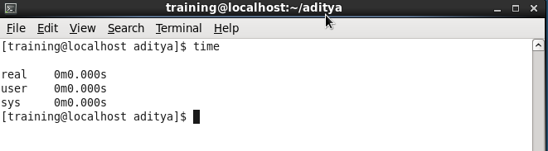

**14. df Command:** The df  command is used to display the disk space used in the file system

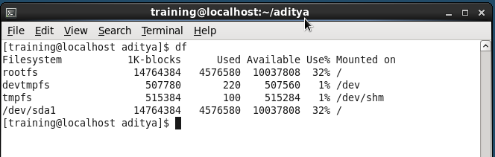

**15. clear Command:** Linux **clear** command is used to clear the terminal screen.

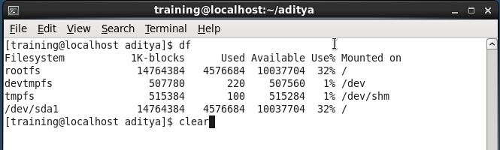

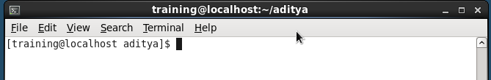

**16. ip Command:** Linux ip  command is an updated version of the ipconfig command. It is used to assign an IP address, initialize an interface, disable an interface

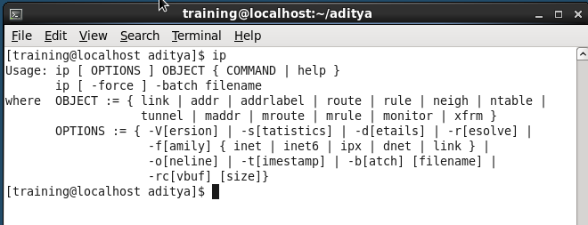

**17.Chmod command:** the chmod command is used to change the access mode of a file.

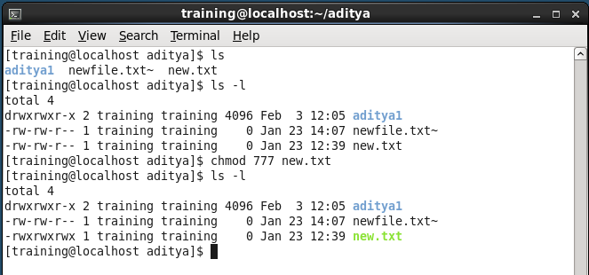

**18.Vi command:** The VI editor is the most popular and classic text editor in the Linux family.

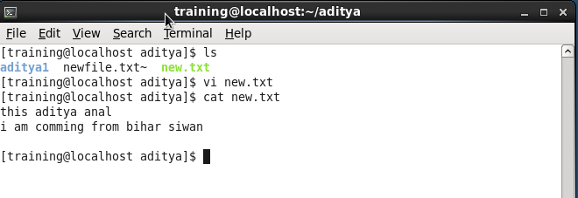

**19. head Command:** The head command is used to display the content of a file. It displays the first 10 lines of a file.

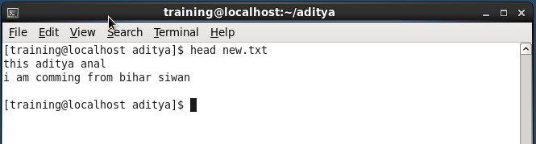

**20. tac Command:** The tac command is the reverse of cat command, as its name specified. It displays the file content in reverse order

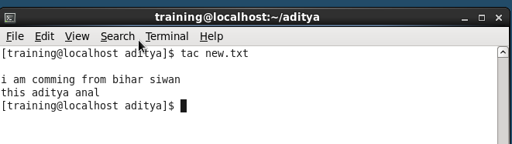

**21.du command:** If you want to check how much space a file or a directory takes up.

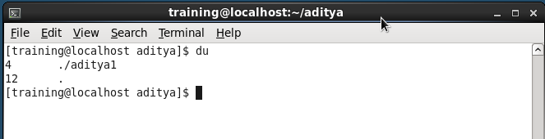

### 22.kill command: Use the kill command to terminate an unresponsive program manually.

### C:\Users\HP\OneDrive\Desktop\linux poto\p23.PNG